2023_SKCET_Cloud_CC1

727721euit045-Hariharan PL

Q1.

Create an EC2 Instance in the us-east-1 region with the following requirements.

1.Give the name tag of both EC2 instance and keypair as “ec2usecase”.

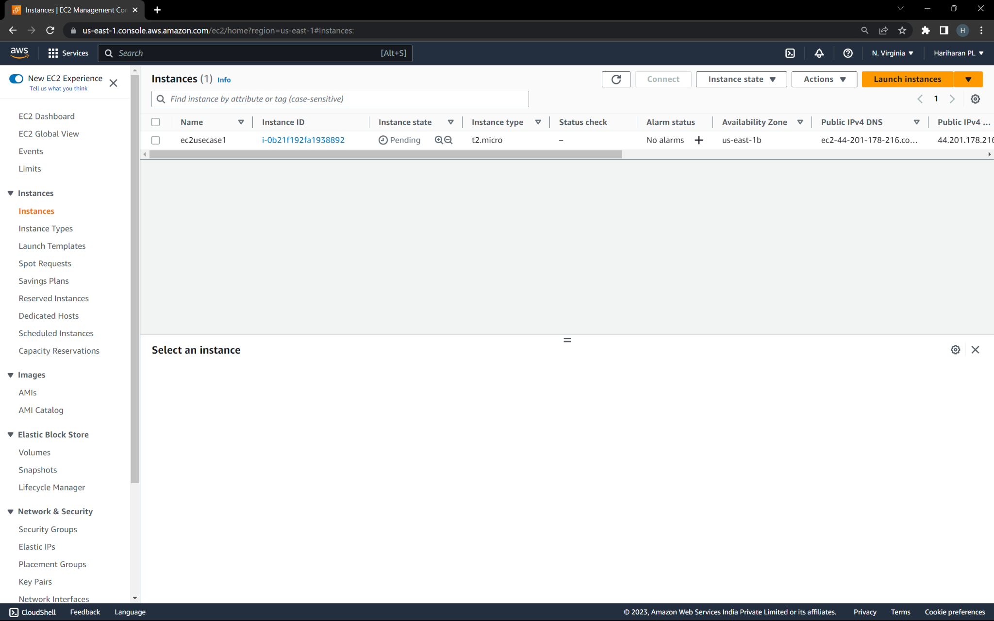

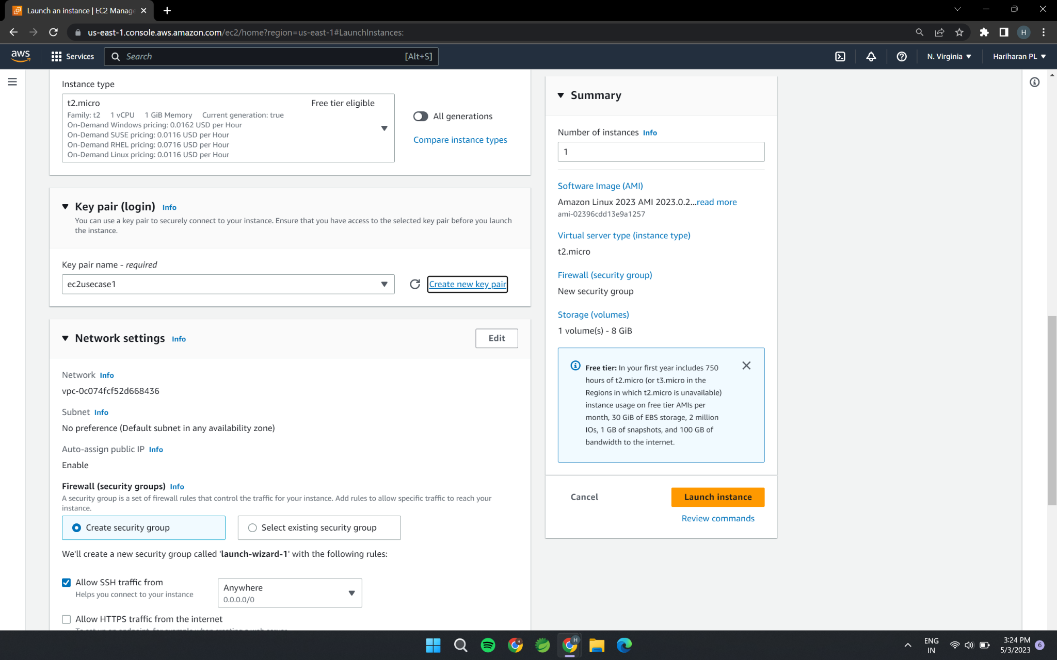

2.EC2 instance AMI should be “Amazon Linux 2”

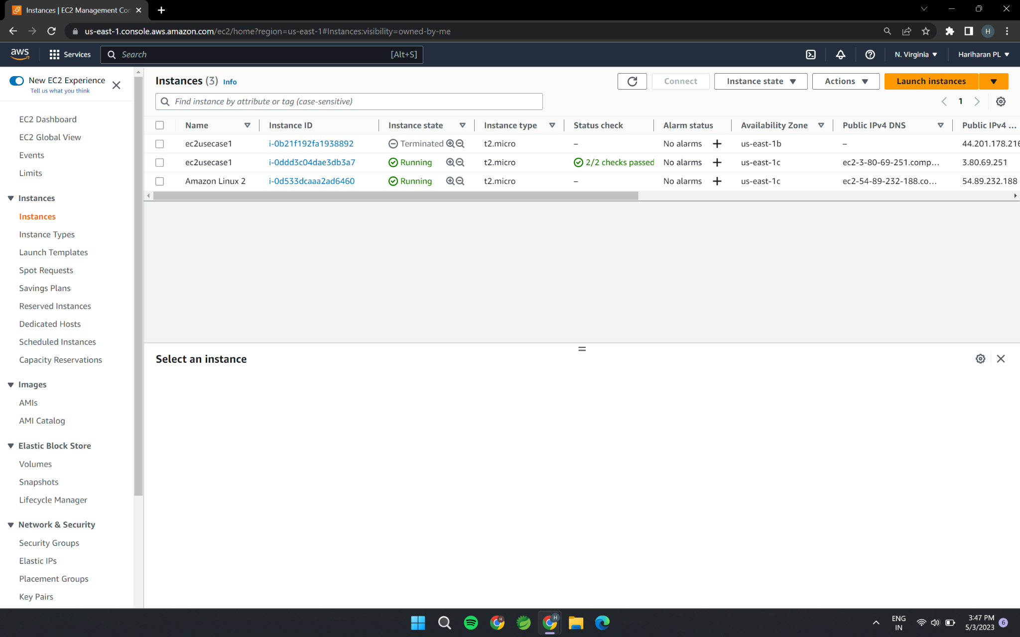

3.Allow SSH traffic for taking putty remote connection



4.Allow HTTP traffic from the internet for reaching website requests.

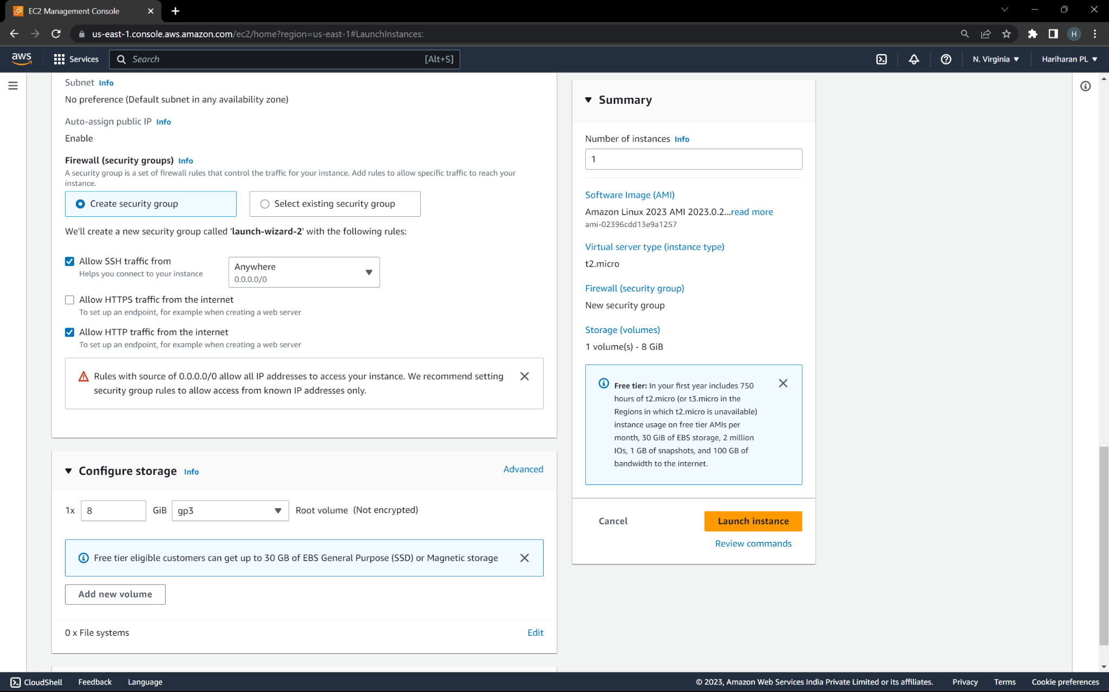

Q2.Create an IAM group called ‘Network-L1-Team’ with ‘AmazonVPCReadOnlyAccess’ and ‘AWSNetworkManagerReadOnlyAccess’ policies,then add an IAM user called ‘Network-L1-User1’ to the group.

1.The name of the IAM group should be ‘Network-L1-Team’.

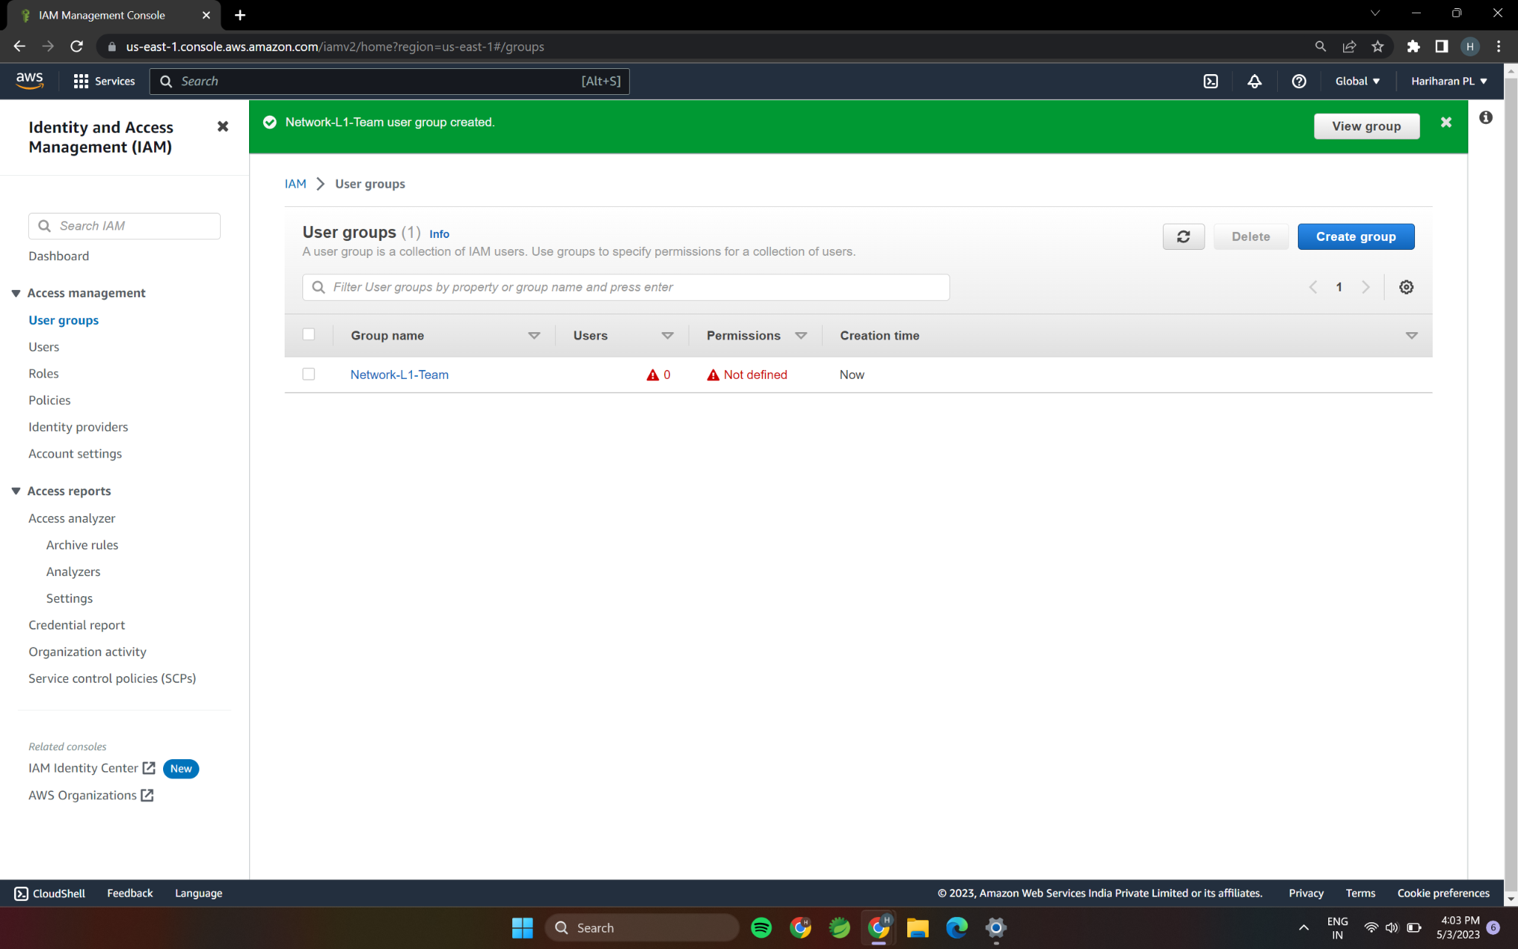

2.The name of IAM user should be ‘Network-L1-User1’.

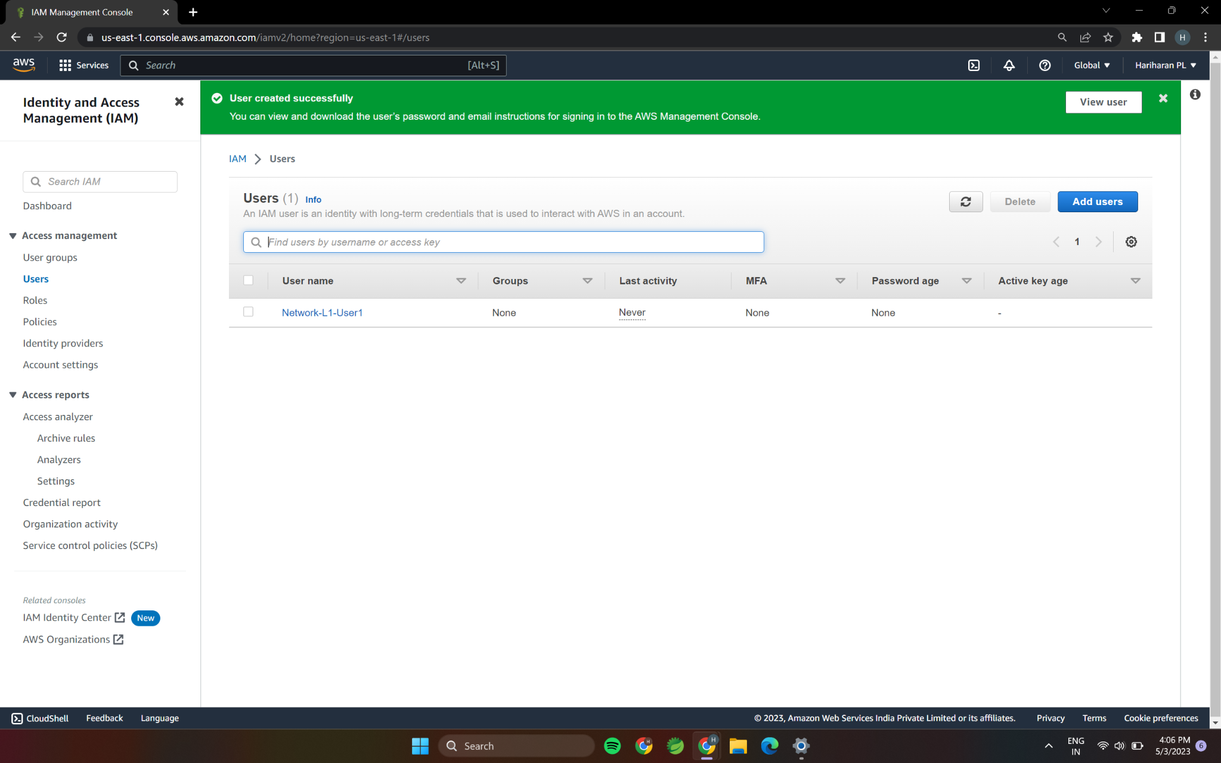

3.The ‘AmazonVPCReadOnlyAccess’ policy should be attached.

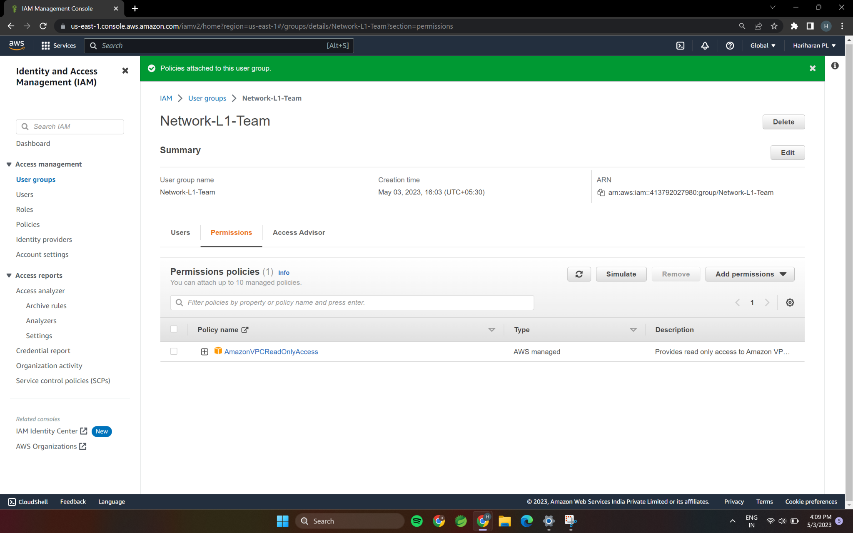

4.The ‘AWSNetworkManagerReadONlyAccess’ policy should be attached.

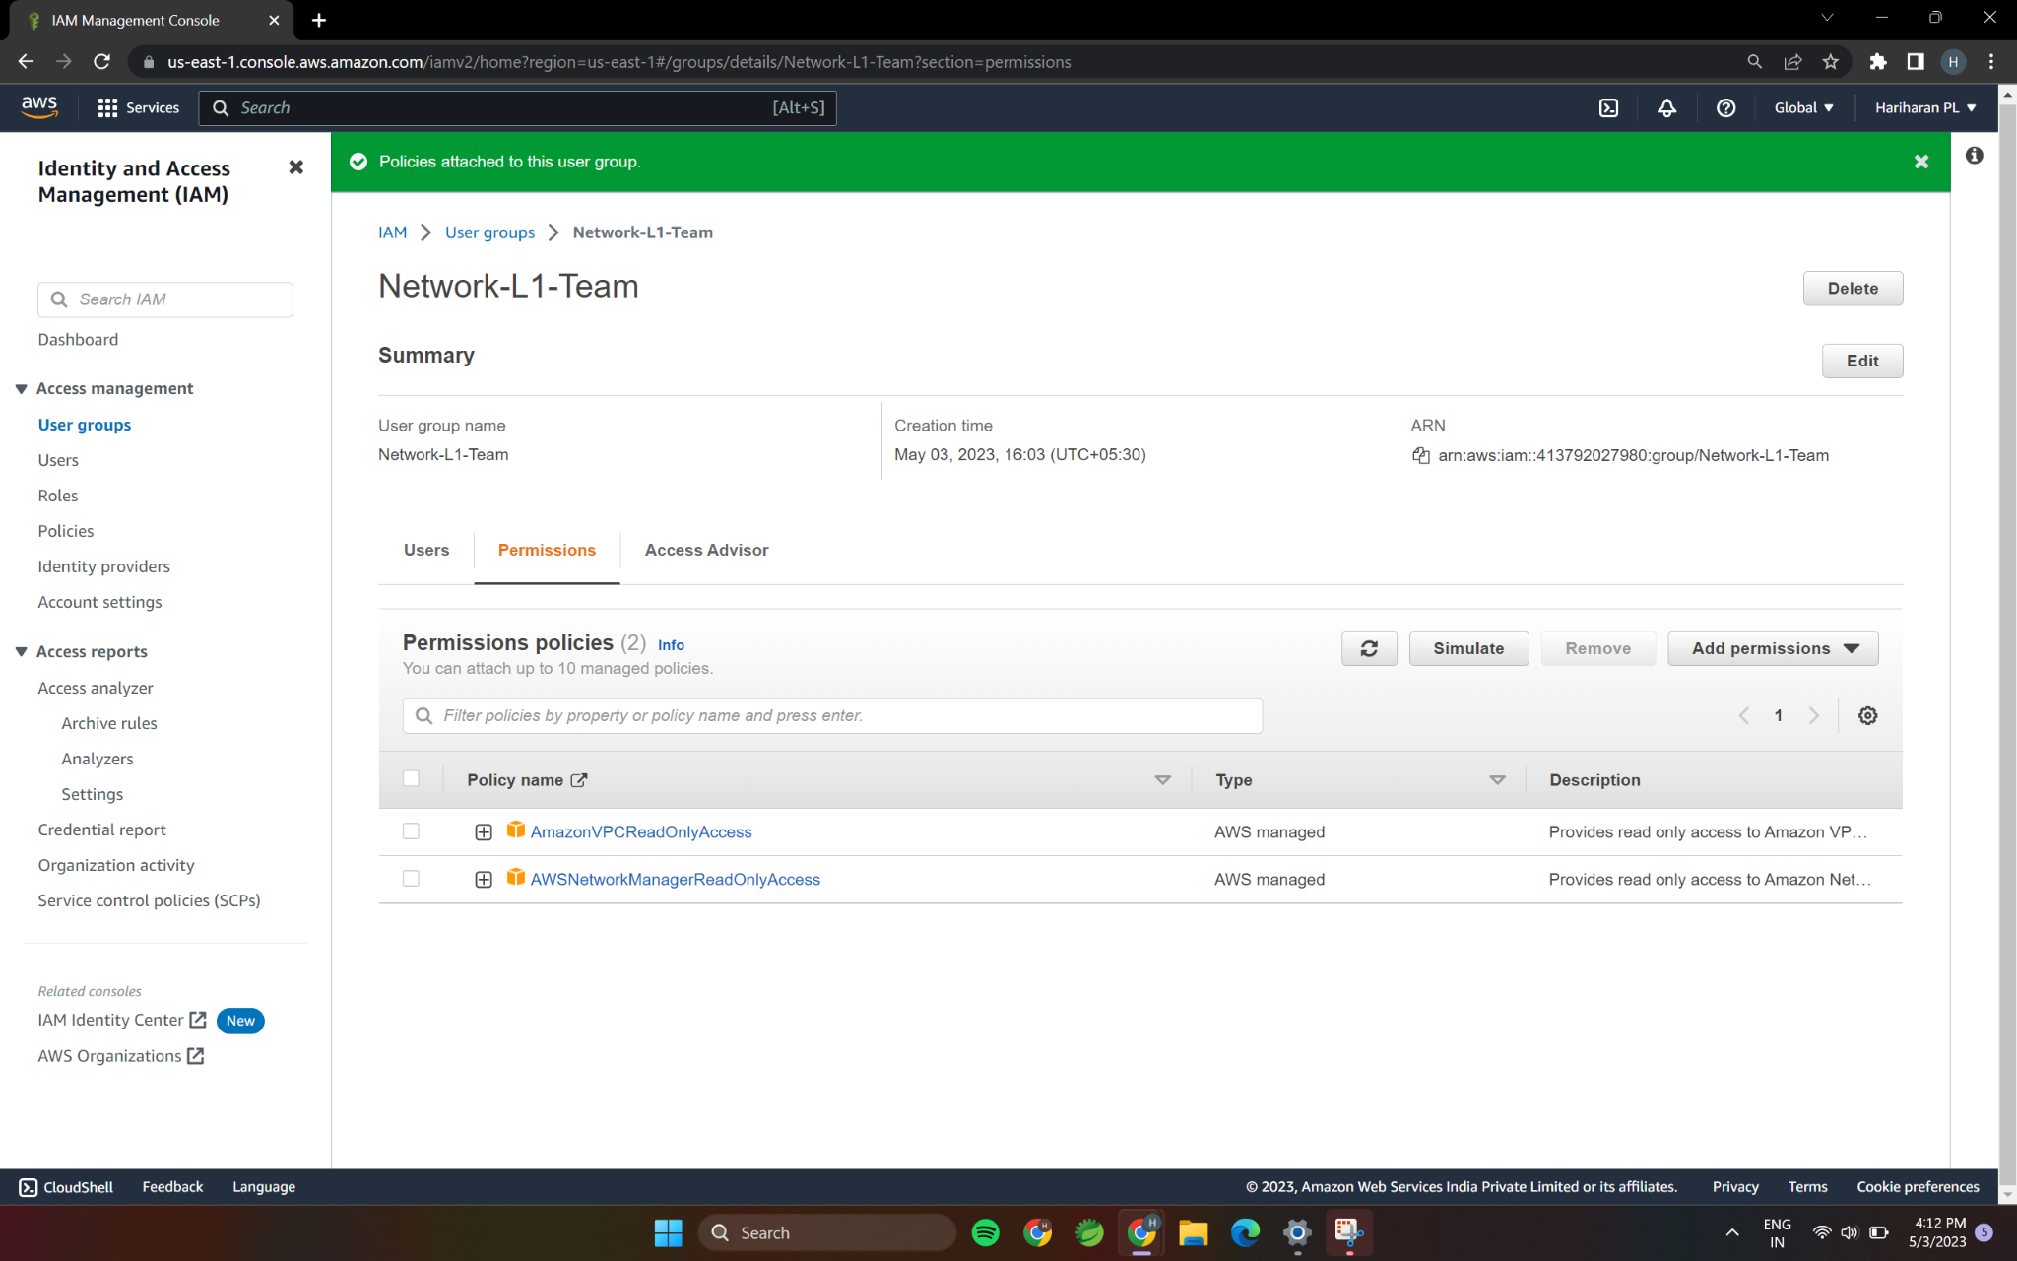

Q3.Create a s3 bucket for the following requirements.

1.Create a new s3 bucket in the region of Stockholm.

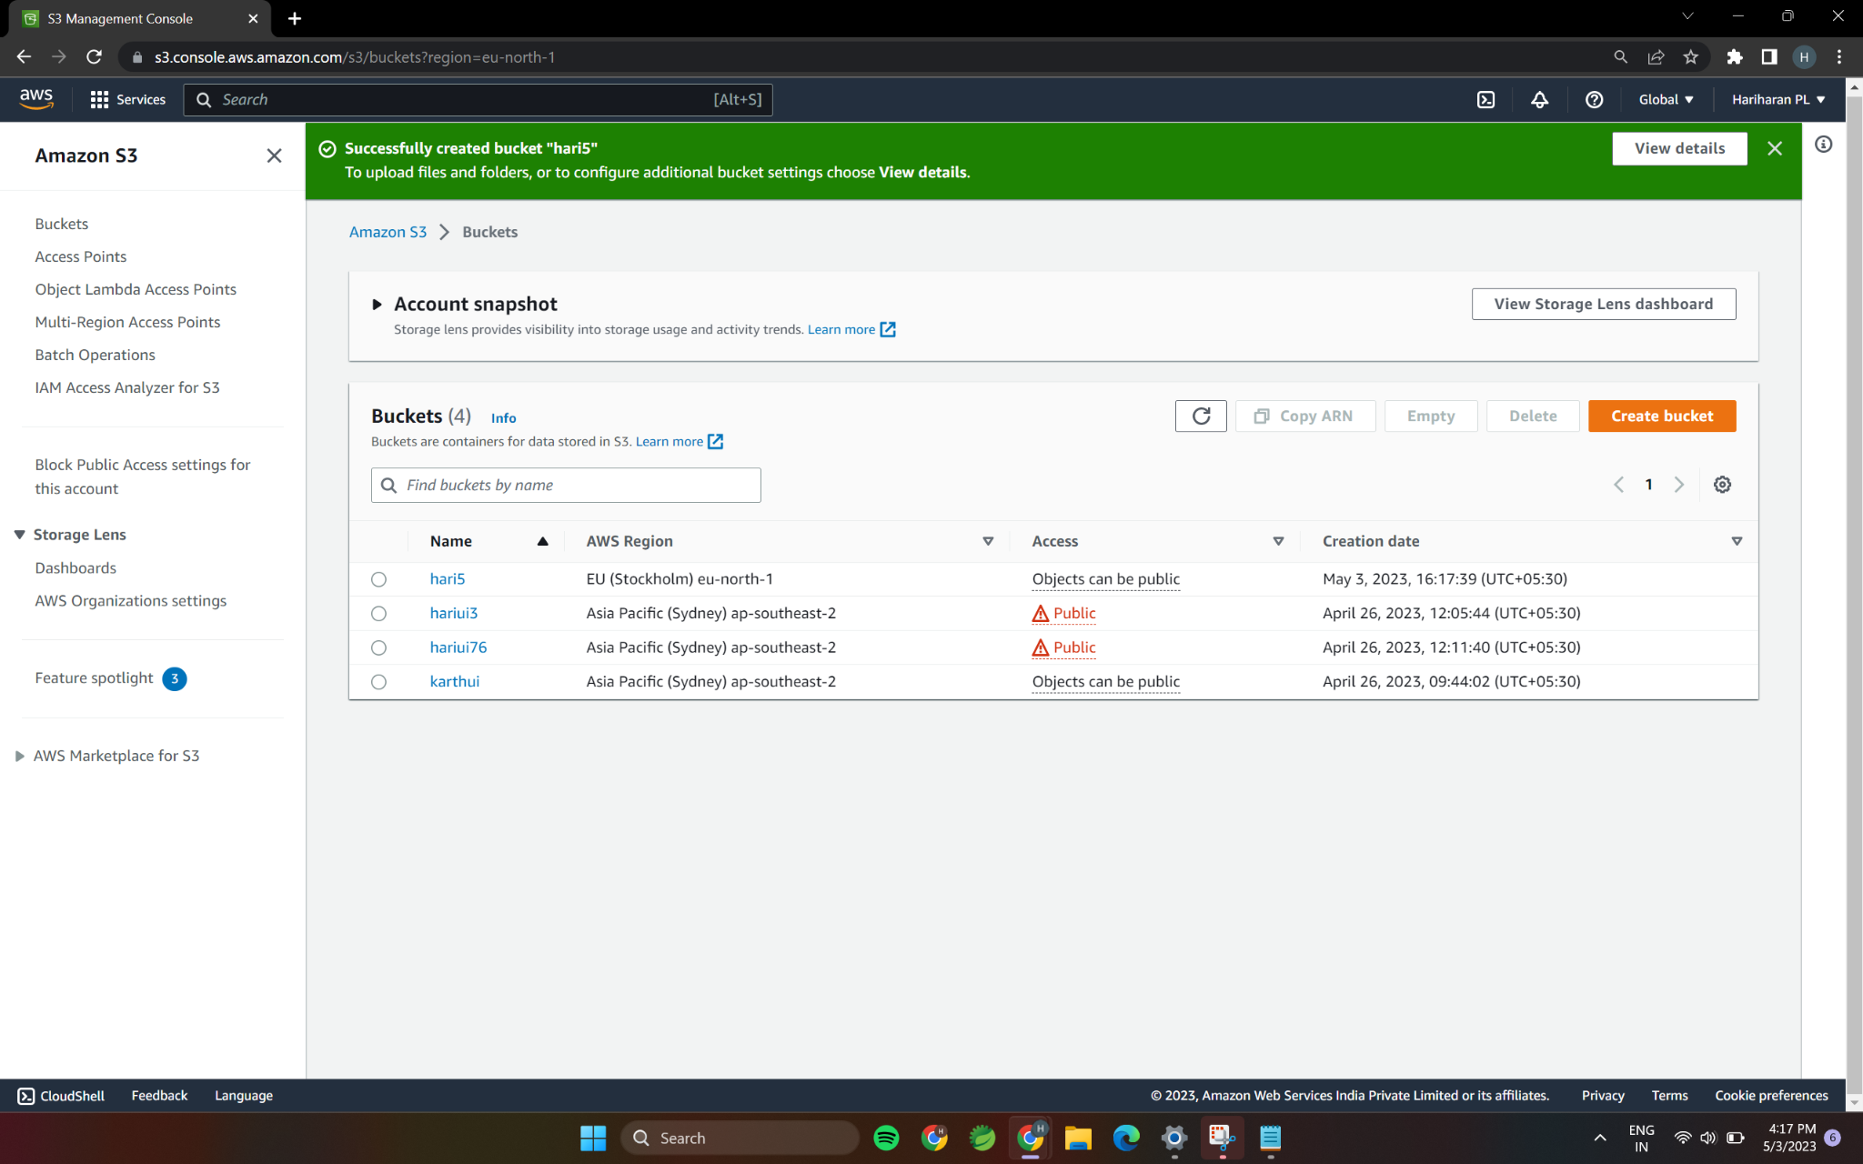

2.Make the bucket available to everyone(publicly) via bucket ACL.

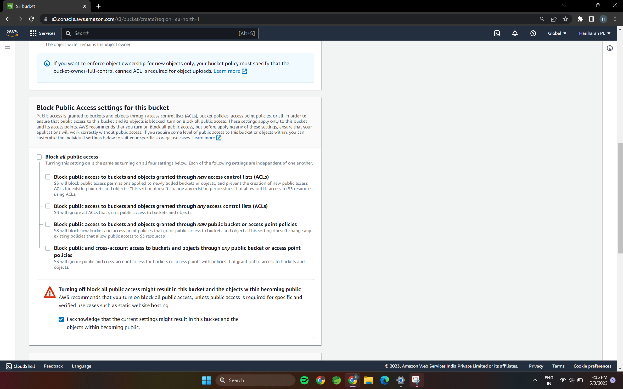

3.Upload the text file in the name of ‘accounts.txt’.

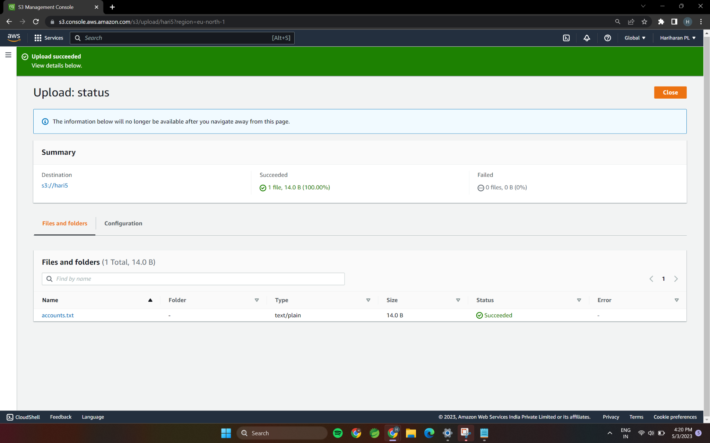

4.Make the object ‘accounts.txt’ file accessible to everyone(publicly)